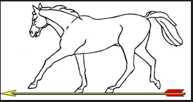

2025 NOMINATION FORM
for
Committee Officers

I wish to propose ___________________________________________________

For the position of ___________________________________________________

Proposed by (please print name & sign) __________________________________________________

Seconded by (please print name & sign) __________________________________________________

Proposal dated _________________________________________________

I agree to stand for the above post _________________________________________________
(please print name & sign)

If elected, I agree that my telephone number – e-mail address (please delete as required) may be displayed on the DWAA website.

Telephone number _____________________________________________

E-mail address _____________________________________________

Completed nomination forms for the positions of the DWAA should be returned to the Secretary DWAA,
email: janeprior1511@gmail.com
to arrive no later than Tuesday 14 October 2025.

