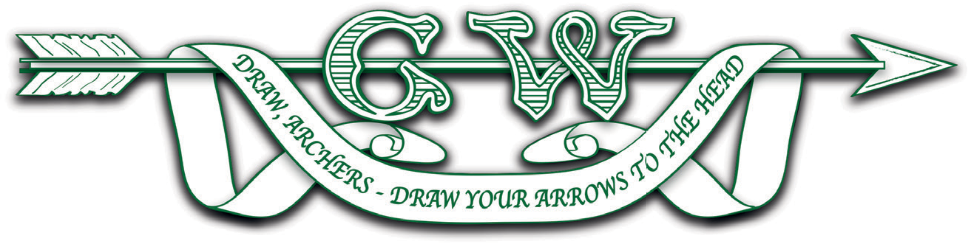
GRAND WESTERN ARCHERY SOCIETY A.G.M. CALLING NOTICE
IN ACCORDANCE WITH CLAUSE 38 OF THE G.W.A.S. CONSTITUTION, I, ANDREW REES, HONORARY SECRETARY OF THE GRAND WESTERN ARCHERY SOCIETY, HEREBY GIVE NOTICE THAT THE ANNUAL GENERAL MEETING OF THE SOCIETY WILL TAKE PLACE ON-LINE AT 5.00 PM ON SUNDAY 21ST MARCH 2021.
AGENDA
1. Apologies for absence.
2. Approval of minutes of the previous AGM.
3. Matters arising.
4. Chairman’s report.
5. Honorary Treasurer’s report, including inter alia:
a. Affiliations Secretary’s report.
b. Presentation and acceptance of the accounts for the year ending 31.12.2020.

6. Affiliation subscriptions: (see attached for the Regional Council’s proposals):
a. For the remainder of 2021 up to 30th September for new members only.
b. For the subscription year 2021/22.

7. Election of Society Officers:
a. President.
b. Chairman.
c. Honorary Secretary.
d. Honorary Treasurer.
8. Election of Society’s specialist officers and members:
a. Hon. Tournament Secretary.
b. Equipment Officer.
c. Junior Representative.
d. Field Representative.
e. Archivist & Librarian.
f. GWAS representatives to EAF.
g. Affiliations Secretary.
h. Protection Officer.
i. Records Officer.
j. Communications and Web Content Officer.
9. To vote on amendments to the GWAS Constitution proposed by the GWAS Council (see attached proposals). Members should note that under Clause 11 of the Constitution such amendments require a majority of two-thirds of those present and voting at the Meeting.
10. To confirm the election of the Regional Coaching Officer.
11. To confirm the election of the Judges’ Liaison Officer.
12. To receive from each County names of representatives to Council for 2021/22.
13. To receive and accept the Hon. Treasurer’s recommendation of a suitable accountant or firm of accountants to prepare accounts under clause 9 of the G.W.A.S. Constitution.

