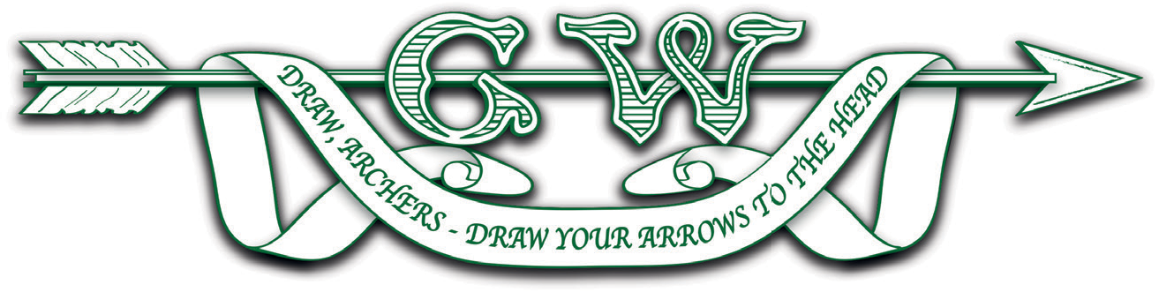
Grand Western Archery Society Annual General Meeting
Notes regarding the online meeting on 21st March 2021

With the continuing COVID-19 epidemic preventing physical gatherings, we are undertaking an Annual General Meeting (A.G.M.) online for the second time in our history. Please bear in mind that this is still a relatively novel way of facilitating this event: as Hon. Secretary, I shall do my best to ensure the business of the Society is transacted efficiently.
COVID-19 restrictions permitting, you will shortly receive a copy of the Hon. Treasurer’s report, the Affiliation Secretary’s report and the minutes of the 2020 A.G.M.. May I ask you to read all these documents prior to the meeting as, in particular, the minutes and Hon. Treasurer’s report need to be formally accepted by the members. Given the limitations of online meetings, may I also ask that any questions relating to these documents are addressed to the Hon. Secretary (secretary@gwas.org.uk) or Hon. Treasurer (treasurer@gwas.org.uk) by noon on Friday 19th March. We shall then endeavour to provide a reasoned answer at the AGM.
Quorum – as you may know, the constitution does not require a quorum for an A.G.M.: this remains the same for the online A.G.M..
The A.G.M. is a private meeting for members of G.W.A.S.. If you wish to join the meeting, would you please register your intention with the Hon. Secretary by noon on Friday 19th March. Please make sure you title your email ‘GWAS AGM attendance’ and include your name, club, AGB number and a contact email address. Current members (that is those affiliated for 2020/2021) will be sent access codes for the meeting around noon on the day of the AGM. This code is for members’ use only and should not be shared with any other person, whether a member of G.W.A.S. or not.
For ease of production of minutes, it is my wish to record the meeting. Whilst it could be argued that there is legitimate interest in doing so under GDP regulations, in this instance I should like the specific consent of each member attending. Therefore, when you register, would you please include the following in your email: ‘I consent to being recorded at the G.W.A.S. A.G.M. and further consent to the recording being kept securely and used only by the G.W.A.S. Hon. Secretary for the purpose of writing minutes of the meeting, with the recording being permanently erased within one month of the meeting.’
If you wish to opt out from the recording or have any concerns about it, please do not hesitate to contact me by email.
Please be aware that the officers of the Association are volunteers and do not have unlimited time for administration. Any members who do not register by noon on the 19th March may request access to the meeting by emailing the Hon. Secretary, but should be aware that their request may not be dealt with in time for the A.G.M., so please register in time.
Members are reminded that this is an A.G.M. which is convened to conduct specific items of business as per the agenda. This means that there will not be any other business from the floor.
Whilst it is not essential, I would urge members to familiarize themselves with the GoToMeeting platform prior to the A.G.M.: please visit https://www.gotomeeting.com/, where you can download a fully functional version of the software at no cost. Try it out! A.G.M. voting (where necessary) will take place online using the software’s chat function, so it would be very beneficial if members could be aware of how it works prior to the meeting.
Access to the meeting will be on the internet via computer, tablet and smartphone and by telephone for voice only access. Access details will be sent to all members who have registered for the meeting prior to the event. The access email will contain the code you will need to ‘attend’ the meeting and will look similar to this:

A meeting
Sun, Aug 23, 2020 2.00 PM - 3:30 PM (BST)
Please join my meeting from your computer, tablet or smartphone.
https://global.gotomeeting.com/join/123456789
You can also dial in using your phone.
United Kingdom: +44 330 221 0097
Access Code: 123-456-789
New to GoToMeeting? Get the app now and be ready when your first meeting starts:
https://global.gotomeeting.com/install/123456789
Meanwhile, I hope to see you at the AGM.
Andrew Rees
Hon. Secretary G.W.A.S.

If you wish to register to attend the A.G.M., I would ask that your request uses the pro forma below:
Name:
Club:
AGB number:
Email address for the delivery of meeting access code:
I consent to being recorded at the G.W.A.S. A.G.M. and further consent to the recording being kept securely and used only by the G.W.A.S. Hon. Secretary for the purpose of writing minutes of the meeting, with the recording being permanently erased within one month of the meeting.

